**PHYSICS:** “Embracing the new competence based curriculum for a better and skilled Uganda”

**S.1 SCENARIO:** Dr. Diana Atwiine, Uganda’s permanent secretary in the ministry of health has started planning for a meeting to host the presidential nation address on “Corona virus” (a pandemic) which is to take place on Monday, 23/03/2020. In the budget, she has planned to host 500 people in State house Entebbe. On consultation with the presidential advisor on social affairs, Dr. Diana has been advised to provide treated water for washing hands by all the participants since doctors have identified washing of hands as a preventive measure to managing the spread of the pandemic Corona Virus. Advisors have provided her with a large metallic tank that will be filled with that water. Dr. Diana has contacted Juma, a primary two drop out but a business man who supplies water in Entebbe town and he has asked her how much water she wants so that he can load his delivery vehicle, unfortunately she has no answer but she has asked him for a few minutes so that she can get the right quantity of water that the tank can accommodate. She has consulted from the presidential advisor who has given her the tank measurements below.

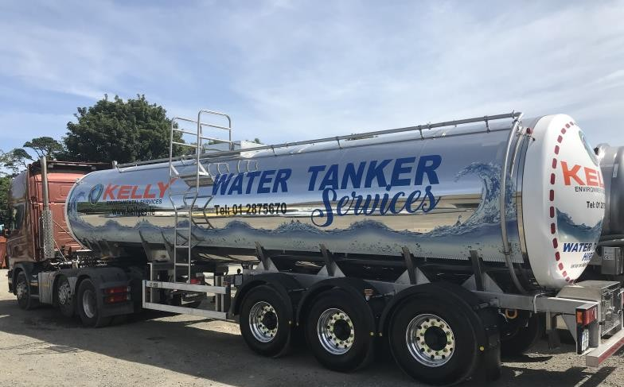

Length = 500cm Width = 200cm Height = 200cm

On receiving these measurements, Dr. Atwiine has failed to obtain the exact amount of water the tank can accommodate, this has left her puzzled and troubled since Juma is waiting for her reply. As a S.1 student of Mpoma School, help Dr. Atwiine come up with the exact amount of water that the tank can accommodate to full capacity.

From the knowledge of physics you have gained from Mpoma School, write a letter to Dr. Diana Atwiine specifying to her the physical quantity she is to deal with and what that physical quantity means, the possible unit (s) she is to indicate on the quantity of water Juma is meant to supply and any measuring instrument (s) that can be used to measure small quantities of that physical quantity in a physics laboratory. In your conclusion, give the exact value indicating the quantity of water Juma is meant to supply with an appropriate unit that Juma will be able to understand.

Customized by Ivan Zizinga (Mr.)-0704834314- **“We lead this race”** S.1-2020

***Corona Virus is real: Avoid shaking hands, giving hugs and any body contact.***

***Wash your hands thoroughly, cover your mouth and nose when coughing and sneezing***